HTML & CSS Assignment: Savanna Brew Café Website
Course: Introduction to Web Development

1. Learning Objectives
By completing this assignment you should be able to:
- Structure web pages with semantic HTML5 elements.
- Link multiple pages together with a consistent navigation system.
- Style pages with an external CSS file (no inline styles).
- Build layouts using Flexbox and/or CSS Grid.
- Use tables, lists, images, and forms correctly.
- Make a website responsive for phones, tablets and desktops.
- Organize project files in a clean folder structure.

2. Case Scenario
Savanna Brew Café is a small, locally owned coffee shop in Westlands, Nairobi. The owner, Mrs. Amina Otieno, sources coffee beans from farms in Nyeri and Kiambu and serves freshly baked snacks. Until now the café has relied on word of mouth and social media. Customers keep asking the same questions: What do you sell? How much does it cost? Where are you? Can I book a table for a group?
Mrs. Otieno has hired you as a junior web developer to build a simple, attractive, multi-page website that:
- Introduces the café and its story.
- Displays the menu with prices in Kenya shillings (KES).
- Shows photos of the café, drinks and food.
- Lets customers send an enquiry and reserve a table.
- Works well on a mobile phone, since most of her customers browse on their phones.
Your task is to design and code this website using only HTML and CSS (no JavaScript, no frameworks such as Bootstrap or Tailwind).

3. Requirements

3.1 Compulsory Pages (minimum five)
# | Page | File name
1 | Home | index.html
2 | About Us | about.html
3 | Menu | menu.html
4 | Gallery | gallery.html
5 | Contact & Reservations | contact.html
You may add extra pages (for example events.html) for bonus marks, but the five above are compulsory.

3.2 HTML Requirements
- Every page must have a valid HTML5 structure: <!DOCTYPE html>, <html lang="en">, <head> and <body>.
- Include <meta charset="UTF-8">, the viewport meta tag, and a unique <title> on each page.
- Use semantic elements: <header>, <nav>, <main>, <section>, <article>, <footer>.
- Use headings in a logical order (one <h1> per page).
- Use at least one ordered or unordered list, one table, and one form.
- All images must have meaningful alt text.
- Use relative links for navigation, and at least one external link that opens in a new tab.

3.3 CSS Requirements
- Use one external stylesheet (css/style.css) linked from every page.
- Do not use inline styles or the <style> tag.
- Use CSS variables (:root) for your colour palette.
- Use Flexbox for the navigation bar and CSS Grid for the gallery (or the other way round, with justification in comments).
- Style links with hover and focus states, and style buttons with a hover effect and a smooth transition.
- Use at least one @media query so the layout adapts at 768px and below.
- Use class and ID selectors sensibly, and comment your CSS in sections.

3.4 Design Rules
- The header, navigation and footer must look identical on every page.
- The current page's link in the navigation must be visually highlighted.
- Keep text readable: sufficient contrast, line-height of at least 1.5, and body font size of at least 16px.

4. Resource Files Provided to Students
Students receive a folder called savanna-brew-resources. If you are the instructor, create the folder as described below. Free images may be downloaded from Unsplash or Pexels, or replaced with solid-colour placeholders.

4.1 Folder Structure (what you must submit)
savanna-brew/
├── index.html
├── about.html
├── menu.html
├── gallery.html
├── contact.html
├── css/
│ └── style.css
└── images/
├── logo.png
├── hero.jpg
├── about-owner.jpg
├── gallery-1.jpg ... gallery-8.jpg
├── latte.jpg
├── croissant.jpg
└── cappuccino.jpg

4.2 Image List
File | Description | Suggested size
logo.png | Coffee cup icon with the text "Savanna Brew" (or a text logo you design) | 200 × 60 px
hero.jpg | Warm photo of the café interior or a steaming cup of coffee | 1600 × 700 px
about-owner.jpg | Portrait of a smiling café owner behind the counter | 600 × 600 px
latte.jpg, cappuccino.jpg, croissant.jpg | Featured items for the home page | 400 × 300 px each
gallery-1.jpg to gallery-8.jpg | Mix of drinks, pastries, customers, and the interior | 600 × 450 px each

4.3 Brand Guidelines
Item | Value
Primary colour (coffee brown) | #6F4E37
Secondary colour (cream) | #F5E9DA
Accent colour (savanna orange) | #D9822B
Dark text | #2B1B12
White | #FFFFFF
Headings font | "Playfair Display", Georgia, serif
Body font | "Open Sans", Arial, sans-serif
Google Fonts links are allowed. Always include fallback fonts.

4.4 Text Content (copy and paste)
Tagline: "Brewed in Kenya. Served with love."
Home page welcome text: Welcome to Savanna Brew Café, your cosy corner in Westlands where every cup tells a story. We roast and brew coffee from the highlands of Nyeri and Kiambu, and pair it with fresh pastries baked every morning. Come in, relax, and taste the difference.
About page, "Our Story": Savanna Brew Café opened in 2019 with one small espresso machine and a big dream: to celebrate Kenyan coffee. Founder Amina Otieno grew up on her grandparents' coffee farm in Nyeri and wanted to bring that flavour to the city. Today the café supports local farmers, uses eco-friendly packaging and hosts community events every month.
About page, "Our Values" (use an unordered list):
- Quality: only freshly roasted, single-origin Kenyan beans.
- Community: fair prices for farmers and a welcoming space for all.
- Sustainability: compostable cups and zero-waste pastries.
Opening hours (use a table on the Contact page):
Day | Hours
Monday to Friday | 7:00 AM to 9:00 PM
Saturday | 8:00 AM to 10:00 PM
Sunday | 9:00 AM to 6:00 PM
Contact details (fictional):
- Address: 14 Coffee Lane, Westlands, Nairobi
- Phone: +254 700 123 456
- Email: hello@savannabrew.example
- Social: Instagram @savannabrew, Facebook /savannabrewcafe

4.5 Menu Data
Hot Drinks
Item | Description | Price (KES)
Espresso | Rich, bold single shot | 200
Cappuccino | Espresso with steamed milk and foam | 300
Caffe Latte | Smooth espresso with creamy milk | 320
Kenyan Chai | Spiced milk tea | 250
Hot Chocolate | Dark chocolate with whipped cream | 350
Cold Drinks
Item | Description | Price (KES)
Iced Latte | Espresso over ice with cold milk | 350
Cold Brew | Steeped for 18 hours | 380
Passion Fruit Cooler | Fresh passion fruit, mint and soda | 300
Bakery and Snacks
Item | Description | Price (KES)
Butter Croissant | Flaky and freshly baked | 250
Banana Bread | Moist, with roasted walnuts | 280
Samosa (2 pieces) | Beef or vegetable | 200
Chocolate Brownie | Rich and fudgy | 300

5. Page-by-Page Design Specification
The wireframes below show the layout each page should follow. Colours, spacing and fine details are up to you, within the brand guidelines.

5.1 Common Elements (all pages)
Header and navigation: logo on the left; links (Home, About, Menu, Gallery, Contact) on the right, laid out with Flexbox. On screens of 768px or less, the links stack vertically below the logo.
Footer: three columns (address, opening hours summary, social links), with a copyright line below: © 2026 Savanna Brew Café. All rights reserved.

5.2 Page 1: Home (index.html)

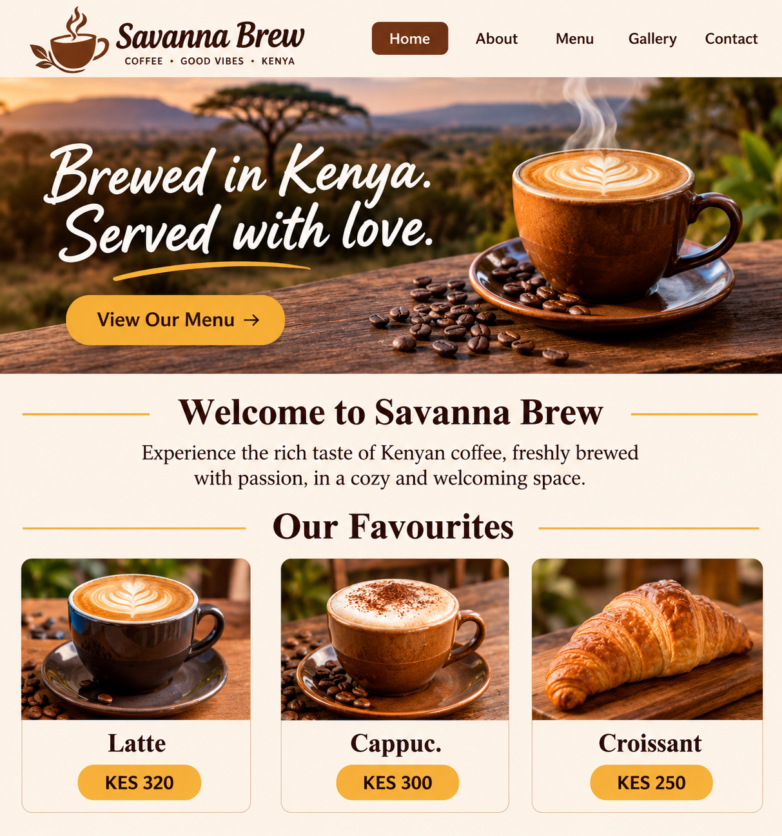
Must include: hero section with text overlaid on a background image, a call-to-action button linking to menu.html, three equal-width cards (Flexbox) with a hover effect (for example, lift with a shadow), and a second button linking to contact.html.

5.3 Page 2: About Us (about.html)
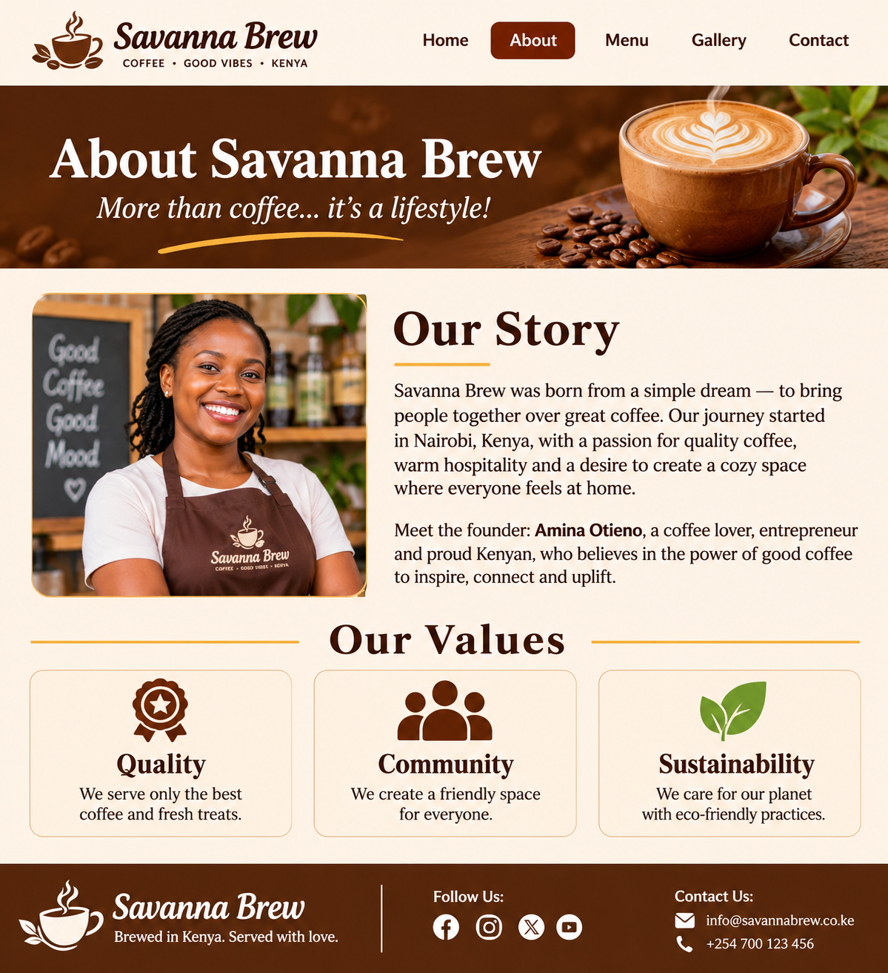
Must include: a two-column layout (image on the left, text on the right) that stacks on mobile, a rounded owner image (border-radius), a values section using a list or three cards, and a block quote from the owner, styled with <blockquote> and a left border.

5.4 Page 3: Menu (menu.html)
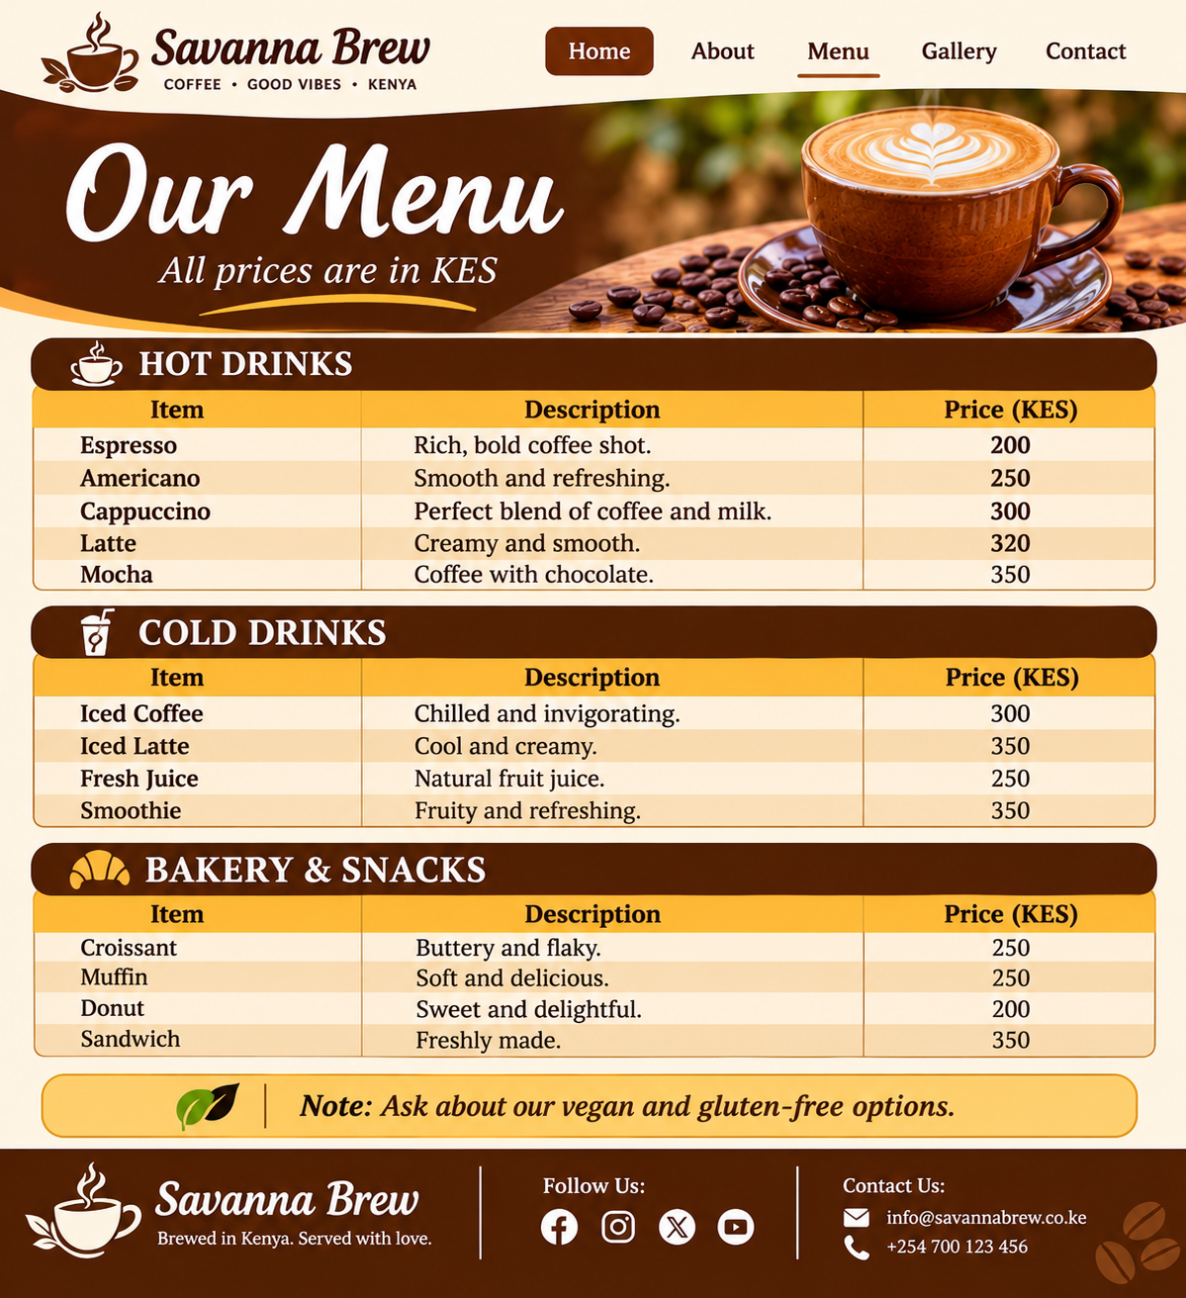
Must include: three HTML tables using <thead>, <tbody> and <th scope>, header row with the primary colour, zebra-striped rows (:nth-child), row hover highlight, right-aligned price column, and a section heading before each table. On mobile, tables must scroll horizontally inside a wrapper (overflow-x: auto) instead of breaking the page.

5.5 Page 4: Gallery (gallery.html)
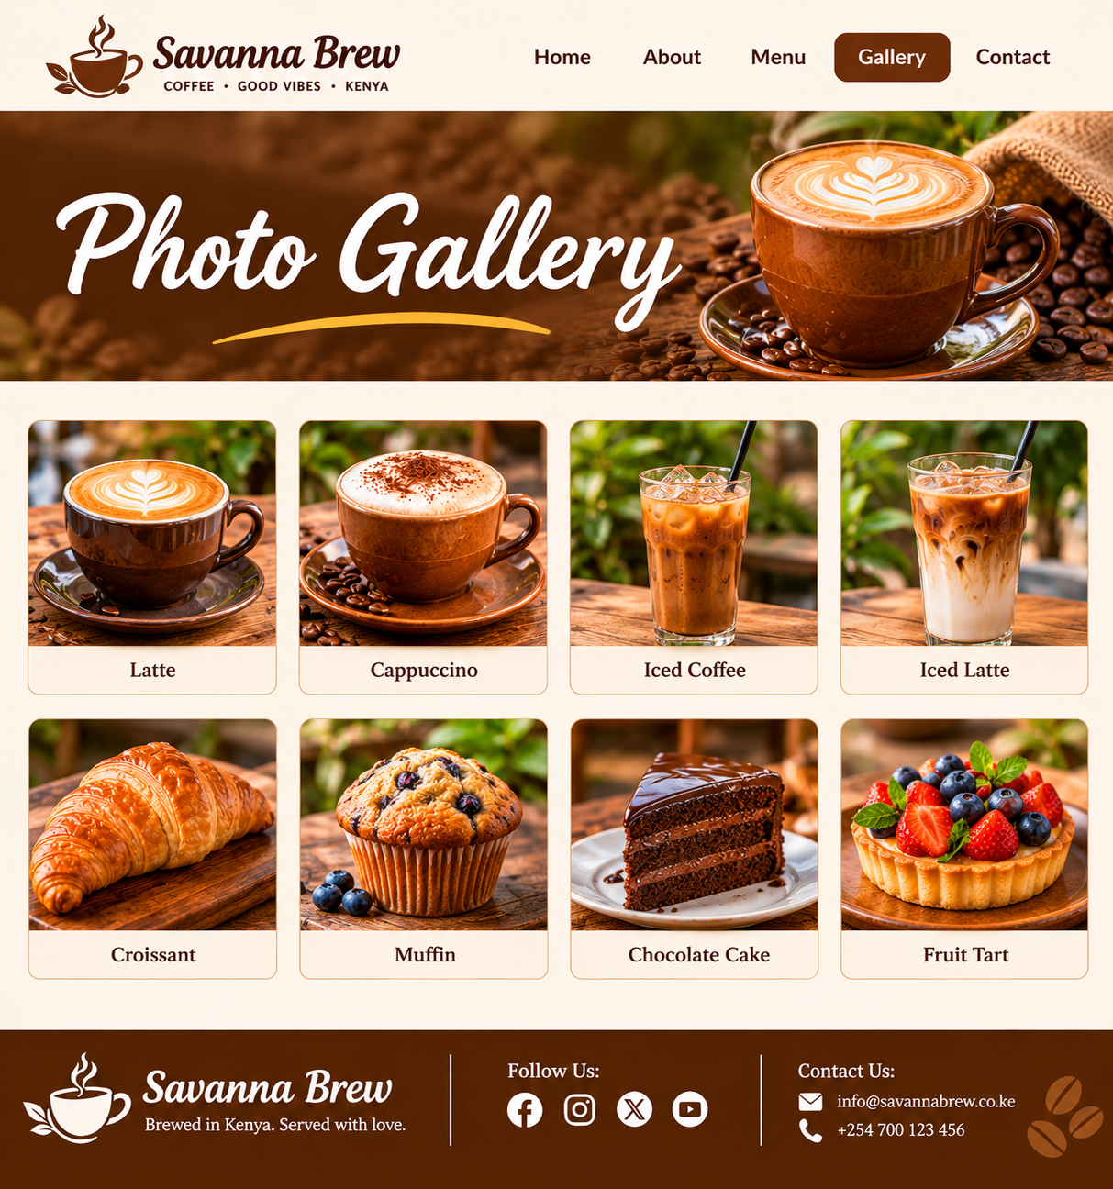
Must include: CSS Grid with 4 columns on desktop, 2 on tablet, 1 on mobile (using repeat() and media queries or auto-fit/minmax()); eight images wrapped in <figure> with <figcaption>; images that fill their cells without distortion (object-fit: cover); and a hover effect such as zoom (transform: scale()) or a caption overlay.

5.6 Page 5: Contact & Reservations (contact.html)
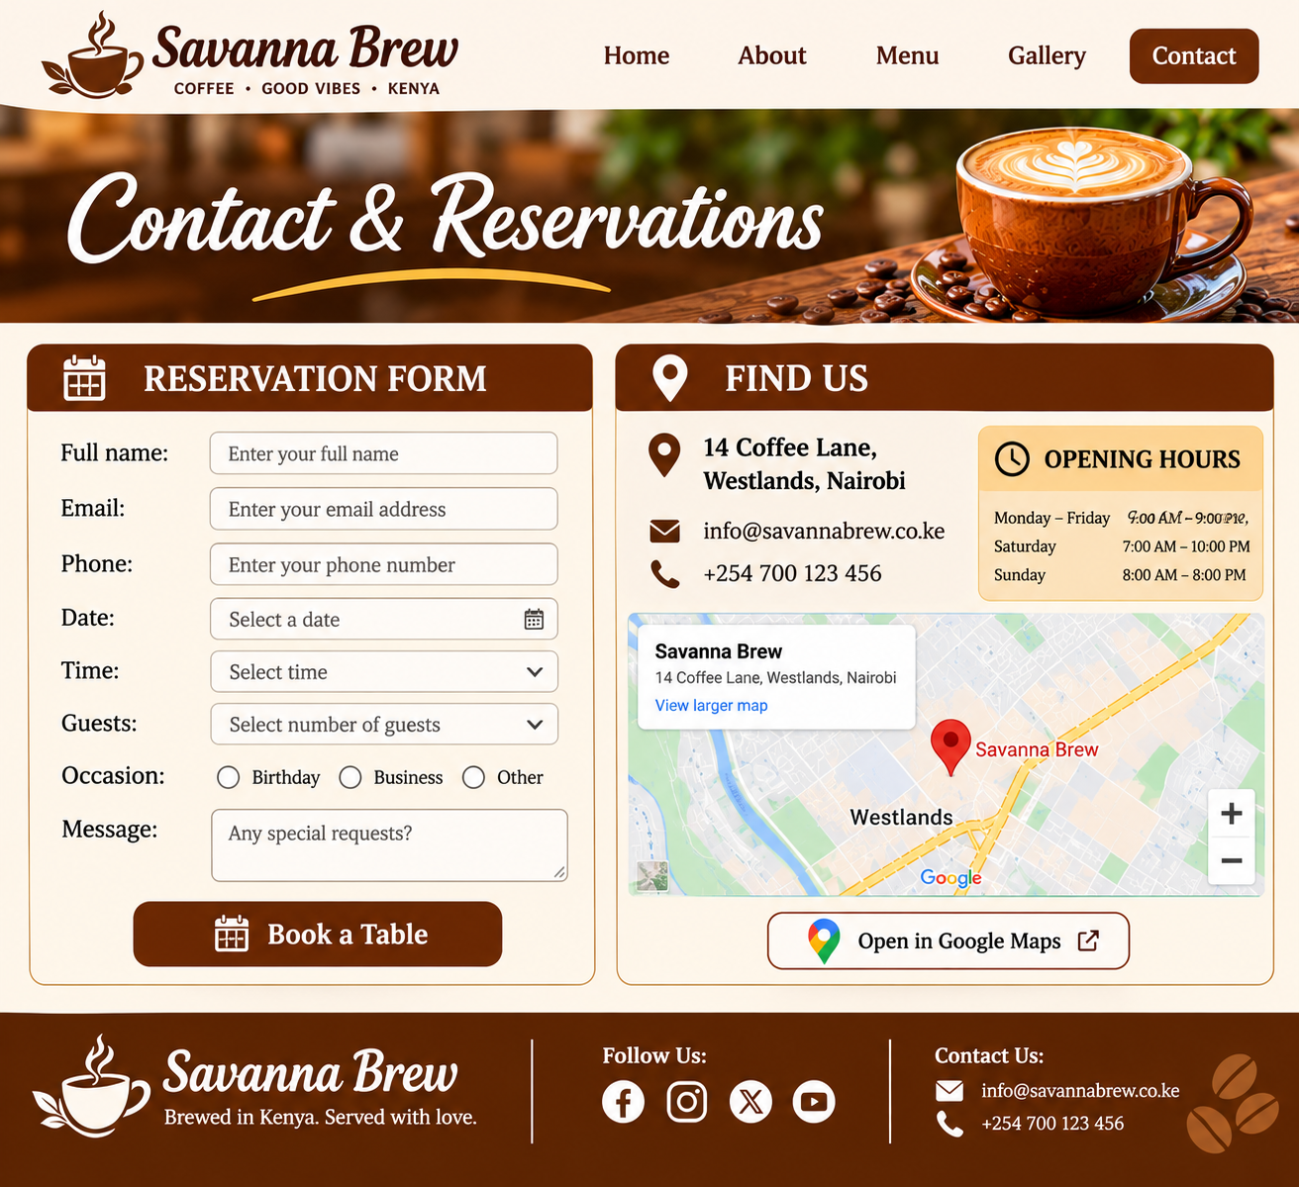
Form must include: <label> linked to each input using for/id; input types text, email, tel, date and time; a <select> for number of guests (1 to 10); radio buttons for occasion (Casual, Birthday, Business); a <textarea> for special requests; required attributes on name, email, date and time; a styled submit button; and <fieldset> and <legend> for the occasion group.
Styling: inputs at 100% width of their column, visible :focus outline in the accent colour, and consistent spacing. The two columns stack on mobile with the form first.

6. Expected Output
When the assignment is complete, the marker should be able to:
- Open index.html in a browser and see the hero section, welcome text, three favourite cards and the call-to-action buttons.
- Click through all five pages using the navigation bar, with the active page highlighted and no broken links or images.
- See the same header and footer on every page.
- View the menu as three neat, striped tables showing prices in KES.
- See the gallery as a responsive grid that changes from 4 to 2 to 1 columns as the window is resized.
- Fill in the reservation form with validation prompts for required fields.
- Resize the browser to 768px or less (or use browser developer tools in phone mode) and see the navigation, columns and tables adapt without horizontal scrolling of the full page.
- Hover over buttons, cards, table rows and gallery images and see visible, smooth effects.

7. Submission Instructions
- Compress the entire savanna-brew folder into a ZIP file named YourName_RegNo_Assignment1.zip.
- Test the site by opening it from the unzipped folder before submitting.
- Validate your HTML at the W3C Markup Validator and CSS at the W3C CSS Validator, and include a short README.txt stating that you validated and listing any remaining warnings.
- Late submissions lose 10% per day.
- Plagiarism (copying another student's code) will result in zero marks. Using code snippets from tutorials is allowed only if you understand them and credit the source in a comment.

8. Marking Scheme (100 marks)
Criteria | Marks
HTML structure and semantics: valid structure, semantic tags, headings, alt text | 20
Navigation and linking: working links, consistent nav, active page highlight | 10
CSS styling: external stylesheet, variables, typography, colour palette, hover and focus states | 20
Layout: Flexbox and Grid used correctly; layouts match the wireframes | 15
Responsiveness: media queries, mobile-friendly tables, images, and navigation | 15
Content completeness: tables, lists, forms, and all provided text and images used | 10
Code quality: indentation, comments, file organisation, meaningful names | 5
Creativity and overall design: polish, consistency, user experience | 5
Total | 100
Bonus (up to 5 marks): an extra page (such as Events), a CSS animation (for example fading in the hero text), a dark-mode style using prefers-color-scheme, or an embedded map using an <iframe>.

9. Helpful Tips
- Build the HTML for all five pages first, then add the CSS.
- Start with the layout for mobile, then add a media query for larger screens (or the reverse), but be consistent.
- Use browser developer tools (F12) to inspect and test your layout.
- Copy your header and footer from index.html into each page so they stay identical.
- Commit to a naming convention for classes (for example .menu-table, .gallery-grid).

10. Instructor Notes (remove before distributing)
- Suggested timeline: Week 1, pages 1 to 3 plus the base CSS. Week 2, pages 4 and 5, responsiveness, validation and submission.
- Common mistakes to watch for: missing alt attributes, inline styles, broken image paths because of folder case sensitivity, forgetting the viewport meta tag, using <br> for spacing instead of CSS, and unlabelled form inputs.
- Sample solution: build a reference solution from the wireframes to check that the task fits the time allowed.

